

**Vehicle Number Plate Detection Using MATLAB**

**Submitted by:**

Muhammad Faizan

**Advised by:**

Mam Kainat Abdullah

Faculty of **Science**

Department of **Computer Science**

May 03, 2024

**University of Agriculture,**

**Faisalabad.**

**Declaration**

I hereby declare that the contents of the project report are my own and no part has been copied

from any published source. I further declare that this project report has not been submitted for

the award of any diploma/degree. The university may act if the information provided is found

incorrect at any stage.

**Certification**

It is certified that Muhammad Faizan has completed the Project“Vehicle Number Plate Detection using Matlab” in partial fulfillment of the requirement for the degree of BS Computer Science under our guidance and supervision.

Signature of Advisory Committee ______________________

**Dedication**

It is with genuine gratitude and warm regard that we dedicate this work to my beloved parents

and teachers. Who did efforts for me and made me able create this project. Also, dedicated to

myself who worked literally day and night to accomplish this task to end.

**Myself**

Hello there, I am Muhammad Faizan, a **3rd** year **Computer Science** student here at University of Agriculture, Faisalabad. I am interested in the field of **Artificial Intelligence (AI)** and **Data Science** and I have been learning and practicing it for the last 2 years now. I learned AI through various online courses on [**Coursera.com**](https://www.coursera.org) and other Esteemed institutions. One of them is [**PIAIC** (Presidential Initiative for Artificial Intelligence & Computing)](https://www.piaic.org/)**.**

Other than that, I am python developer and I have been working in python language in my development having a firm grip on various python libraries that are being used in Data Science. Some of them are **Pandas**, **Numpy**, **Matplotlib**, **Seaborn**, **Plotly**, **Scikit-learn**, **tensorflow** and many more.

* You can reach me out for any guidance or collaboration in projects related to my field of interest.

: [kaggle.com/faizanyousafonly](https://www.kaggle.com/faizanyousafonly)

: [linkedin.com/in/mrfaizanyousaf/](https://www.linkedin.com/in/mrfaizanyousaf/)

: [github.com/faizan-yousaf/](https://github.com/faizan-yousaf/)

:[Instagram.com/photography_by_fazi/](https://Instagram.com/photography_by_fazi/)

**Title: Advancing Road Safety:**

**Vehicle Number Plate Detection with MATLAB**

In today's dynamic transportation landscape, ensuring road safety is paramount. "Vehicle Number Plate Detection using MATLAB" offers a vital solution. By harnessing MATLAB's computational prowess, this project enables swift and accurate identification of vehicles.

From enforcing traffic regulations to enhancing security, its impact is far-reaching. This initiative not only addresses immediate concerns like accidents and theft but also embodies the transformative potential of technology in fostering safer roadways.

**Methodology:**

The followings are the steps that are performed during the whole process:

1. **Image Preprocessing**:

- The code begins by reading an image of a car.

- It then converts the image to grayscale, simplifying subsequent processing steps.

- A dilation operation is applied to the grayscale image to remove noise. Dilation enhances the boundaries of objects in an image, making them easier to detect.

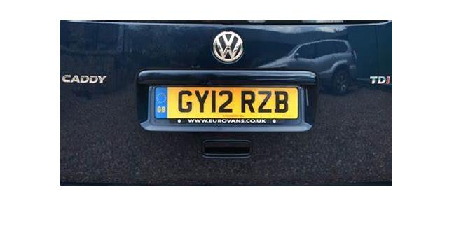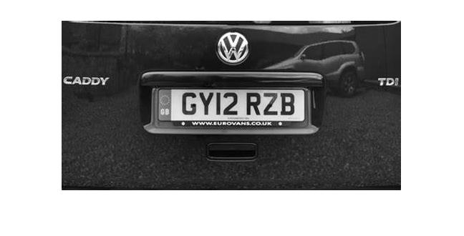

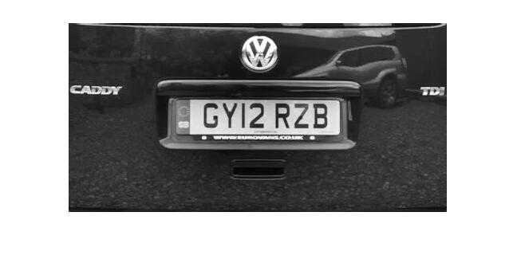

2. **Edge Detection:**

- Edge detection is crucial for identifying the boundaries of objects, such as the number plate on a vehicle.

- The code processes edges both horizontally and vertically within the image.

- For each direction, it calculates the difference in intensity between adjacent pixels. Significant differences indicate potential edges.

- Histograms are constructed to visualize the distribution of edge intensities.

- To smooth the histograms and reduce noise, a low-pass filter is applied.

- Histogram values below a dynamically determined threshold are filtered out to focus on prominent edges.

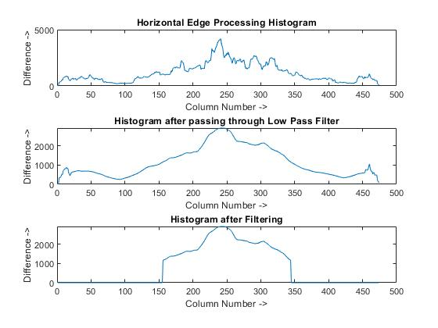

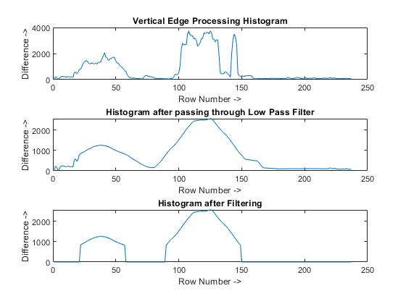

3. **Peak Detection:**

- Peak detection is performed on the smoothed histograms to identify regions with the highest edge intensity.

- Peaks in both the horizontal and vertical histograms indicate potential locations for the number plate.

- These peak values are crucial for determining the most probable regions where the number plate is likely to be located.

4. **Region of Interest Extraction:**

- Based on the identified peaks, the code extracts regions of interest (ROI) that are most likely to contain the number plate.

- Non-probable regions are removed from the image to refine the detection process.

- The final result is an image highlighting the potential number plate regions, ready for further analysis or processing.

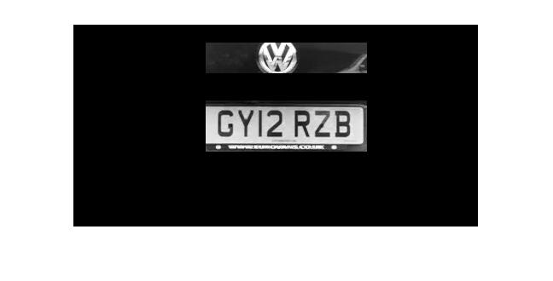

5. **Displaying Results:**

- The code provides visual feedback at various stages of the process.

- It displays the original image, the dilated image (after noise removal), histograms showing edge intensity distributions, and the final image with identified number plate regions highlighted.

By implementing these functionalities, the code lays the groundwork for a robust vehicle number plate detection system, facilitating tasks such as automated license plate recognition (ALPR) and traffic monitoring.

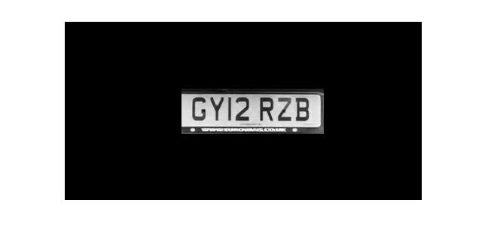

**Matlab Code:**

clc; % Clear command window.

clear all; % Delete all variables.

close all; % Close all figure windows except those created by imtool.

imtool close all; % Close all figure windows created by imtool.

workspace; % Make sure the workspace panel is showing.

**% Read Image**

I = imread ('CAR2.jpg');

figure(1);

imshow(I);

% Extract Y component (Convert an Image to Gray)

Igray = rgb2gray(I);

[rows cols] = size(Igray);

**% Dilate and Erode Image in order to remove noise**

Idilate = Igray;

for i = 1:rows

for j = 2:cols-1

temp = max(Igray(i,j-1), Igray(i,j));

Idilate(i,j) = max(temp, Igray(i,j+1));

end

end

I = Idilate;

figure(2);

imshow(Igray);

figure(3);

title('Dilated Image')

imshow(Idilate);

figure(4);

imshow(I);

difference = 0;

sum = 0;

total_sum = 0;

difference = uint32(difference);

**% PROCESS EDGES IN HORIZONTAL DIRECTION**

disp('Processing Edges Horizontally...');

max_horz = 0;

maximum = 0;

for i = 2:cols

sum = 0;

for j = 2:rows

if(I(j, i) > I(j-1, i))

difference = uint32(I(j, i) - I(j-1, i));

else

difference = uint32(I(j-1, i) - I(j, i));

end

if(difference > 20)

sum = sum + difference;

end

end

horz1(i) = sum;

% Find Peak Value

if(sum > maximum)

max_horz = i;

maximum = sum;

end

total_sum = total_sum + sum;

end

average = total_sum / cols;

figure(5);

**% Plot the Histogram for analysis**

subplot(3,1,1);

plot (horz1);

title('Horizontal Edge Processing Histogram');

xlabel('Column Number ->');

ylabel('Difference ->');

**% Smoothen the Horizontal Histogram by applying Low Pass Filter**

sum = 0;

horz = horz1;

for i = 21:(cols-21)

sum = 0;

for j = (i-20):(i+20)

sum = sum + horz1(j);

end

horz(i) = sum / 41;

end

subplot(3,1,2);

plot (horz);

title('Histogram after passing through Low Pass Filter');

xlabel('Column Number ->');

ylabel('Difference ->');

**% Filter out Horizontal Histogram Values by applying Dynamic Threshold**

disp('Filter out Horizontal Histogram...');

for i = 1:cols

if(horz(i) < average)

horz(i) = 0;

for j = 1:rows

I(j, i) = 0;

end

end

end

subplot(3,1,3);

plot (horz);

title('Histogram after Filtering');

xlabel('Column Number ->');

ylabel('Difference ->');

**% PROCESS EDGES IN VERTICAL DIRECTION**

difference = 0;

total_sum = 0;

difference = uint32(difference);

disp('Processing Edges Vertically...');

maximum = 0;

max_vert = 0;

for i = 2:rows

sum = 0;

for j = 2:cols %cols

if(I(i, j) > I(i, j-1))

difference = uint32(I(i, j) - I(i, j-1));

end

if(I(i, j) <= I(i, j-1))

difference = uint32(I(i, j-1) - I(i, j));

end

if(difference > 20)

sum = sum + difference;

end

end

vert1(i) = sum;

**% Find Peak in Vertical Histogram**

if(sum > maximum)

max_vert = i;

maximum = sum;

end

total_sum = total_sum + sum;

end

average = total_sum / rows;

figure(6)

subplot(3,1,1);

plot (vert1);

title('Vertical Edge Processing Histogram');

xlabel('Row Number ->');

ylabel('Difference ->');

**% Smoothen the Vertical Histogram by applying Low Pass Filter**

disp('Passing Vertical Histogram through Low Pass Filter...');

sum = 0;

vert = vert1;

for i = 21:(rows-21)

sum = 0;

for j = (i-20):(i+20)

sum = sum + vert1(j);

end

vert(i) = sum / 41;

end

subplot(3,1,2);

plot (vert);

title('Histogram after passing through Low Pass Filter');

xlabel('Row Number ->');

ylabel('Difference ->');

**% Filter out Vertical Histogram Values by applying Dynamic Threshold**

disp('Filter out Vertical Histogram...');

for i = 1:rows

if(vert(i) < average)

vert(i) = 0;

for j = 1:cols

I(i, j) = 0;

end

end

end

subplot(3,1,3);

plot (vert);

title('Histogram after Filtering');

xlabel('Row Number ->');

ylabel('Difference ->');

figure(7), imshow(I);

**% Find Probable candidates for Number Plate**

j = 1;

for i = 2:cols-2

if(horz(i) ~= 0 && horz(i-1) == 0 && horz(i+1) == 0)

column(j) = i;

column(j+1) = i;

j = j + 2;

elseif((horz(i) ~= 0 && horz(i-1) == 0) || (horz(i) ~= 0 && horz(i+1) == 0))

column(j) = i;

j = j+1;

end

end

j = 1;

for i = 2:rows-2

if(vert(i) ~= 0 && vert(i-1) == 0 && vert(i+1) == 0)

row(j) = i;

row(j+1) = i;

j = j + 2;

elseif((vert(i) ~= 0 && vert(i-1) == 0) || (vert(i) ~= 0 && vert(i+1) == 0))

row(j) = i;

j = j+1;

end

end

[temp column_size] = size (column);

if(mod(column_size, 2))

column(column_size+1) = cols;

end

[temp row_size] = size (row);

if(mod(row_size, 2))

row(row_size+1) = rows;

end

**% Region of Interest Extraction**

%Check each probable candidate

for i = 1:2:row_size

for j = 1:2:column_size

**% If it is not the most probable region remove it from image**

if(~((max_horz >= column(j) && max_horz <= column(j+1)) && (max_vert >=row(i) && max_vert <= row(i+1))))

**%This loop is only for displaying proper output to User**

for m = row(i):row(i+1)

for n = column(j):column(j+1)

I(m, n) = 0;

end

end

end

end

end

figure(8), imshow(I);

imshow(I);

**Future Scope:**

The project "Vehicle Number Plate Detection using MATLAB" holds immense potential for future applications, particularly in the realm of crime prevention and addressing various societal concerns. Here are some potential future scopes:

**1**. **Automated Law Enforcement**:

- Integration with surveillance systems and law enforcement databases can enable automated detection of vehicles involved in criminal activities, such as stolen cars, unregistered vehicles, or those associated with suspects of interest.

- Real-time identification of vehicles with expired registration or outstanding violations can facilitate proactive law enforcement actions, contributing to enhanced public safety.

**2. Crime Investigation and Forensics:**

- Vehicle number plate detection can aid in forensic investigations by providing crucial evidence linking vehicles to specific locations or incidents.

- Integration with other surveillance technologies, such as CCTV cameras, can provide comprehensive coverage and facilitate the reconstruction of events for investigative purposes.

**3. Border Security and Customs Enforcement:**

- Deploying the system at border crossings and customs checkpoints can assist in identifying vehicles involved in smuggling activities, trafficking of illicit goods, or illegal immigration.

- Automated screening of vehicles entering or leaving sensitive areas can enhance border security measures and help prevent cross-border crimes.

**4. Integration with Smart City Initiatives:**

- Integration with smart city frameworks can enable seamless data sharing and interoperability with other urban systems, such as transportation management, public safety, and emergency response.

In summary, the future scope of the project extends beyond mere number plate detection to encompass a range of applications with far-reaching implications for crime prevention, public safety, and urban development. By harnessing advancements in technology and data analytics, the project can play a pivotal role in addressing emerging challenges and creating smarter, safer communities.

**Conclusion:**

In conclusion, "Vehicle Number Plate Detection using MATLAB" is poised to significantly improve road safety and address societal concerns. With its precise identification capabilities, the project offers potential for crime prevention, law enforcement, and urban planning. By leveraging advanced algorithms and integration with existing systems, it provides a proactive solution to combat vehicle-related crimes, manage traffic effectively, and promote environmental sustainability. As technology evolves, this project stands as a beacon for creating safer, smarter communities.